
A 10

Sreenidhi Institute of Science & Technology
(An Autonomous Institution)
Code No: 102CC02
M. TECH. I – Year I – Semester Examinations, March, 2011 (Regular)
Finite Element Analysis (CAD/CAM)

Time: 3 Hours Max. Marks : 60

Note : No additional answer sheets will be provided.

* * * * *
Part-A (Objective Type)
Max.Marks:10

Answer all the QUESTIONS.

1. Distinguish between plane stress and plane strain condition.

2. Derive the nodal load vector for a bar subjected to temperature rise.

3. Distinguish Iso-parametric, sub parametric and super parametric elements.

4. Explain the meaning of Eigen value. Differentiate between the lumped and consistent mass.

5. What is non - linearity? Name the methods to solve the material non-linear problems.

Part – B (Subjective Type)
Max.Marks: 50
Answer any Five. All questions carry equal marks.

1. Find the nodal displacements, element stresses and support reactions for the axial bar supported between rails as shown in figure : 1
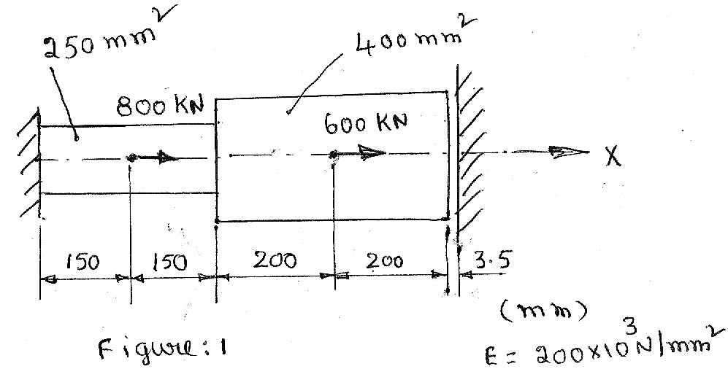

2. Find the displacements at the point of load application for the beam shown in figure : 2, by considering two beam elements.
E = 100 GPa.
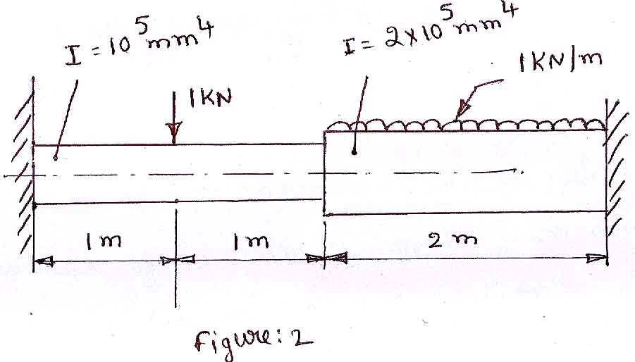
3. Derive the load vector for the CST element when one of its subjected to variable pressure loading as shown in figure : 3, also a body force of 25 N/mm³ acting downwards.
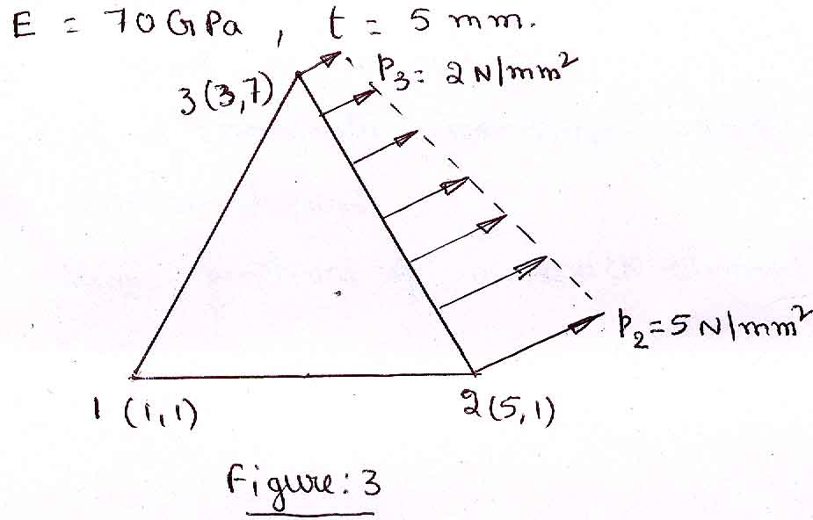

4. Derive the formulation of finite element equations for one dimensional conduction heat transfer problems.

5. Determine the approximate first two natural frequencies of a simply supported beam using one element. Also shown their mode shapes.

6. a) Explain any two methods to solve material non - linearity problems.

b) Derive the Jaco bian for a four - noded quadrilateral element.

7. Write short noted on
a) Natural co-ordinates and shape functions of a beam element.

b) Shape functions of a brick element.

